COLLEGE OF ENGINEERING, TRIVANDRUM
THIRUVANANTHAPURAM – 695 016



DEPARTMENT OF
COMPUTER SCIENCE AND ENGINEERING

A Project Report
on

ONLINE DIARY
Using LAMP stack

Submitted by

ABHISHEK T TVE17CS004
ABDUL KHADER P V LTVE17CS063
HISHAM ALI P LTVE17CS066

Under the guidance
of

THANIA KUMAR

CONTENTS

1. Introduction 1

2. System Requirements and Specifications 2
2.1 Hardware Requirements
2.2 Software Requirements
2.2.1 Linux
2.2.2 Apache
2.2.3 My-SQL
2.2.4 PHP

3. LAMP Server Installation 3
3.1 Default Installation
3.2 Apache Installation
3.3 PHP Installation

4. Setting up My-SQL 4
4.1 Set MySQL bind address
4.2 Set MySQL root password

5. System Design 5
5.1 Module Description
5.2 Database Design
5.3 Form Design 6

6. Conclusion 8

7. References 9
Chapter 1
INTRODUCTION

Even when carefully kept, paper journals can be read by anyone who happens upon them. Online-Diary is a web application to keep track of your past and think about your future. Online Diary keeps your journals safe with a safe password protection so you can rest easy knowing that your entries are secure. You can make predictions about what will happen and see if they come true, and you can see how you changed over time, and read over memories, having a few laughs.
Take your journals wherever you go with the Online-Diary, a web application which can be used in PCs, Smart Phones and Tablets with an internet access. Write down a note or a thought on your notebook, mobile phone or tablet and transform it into a memory to keep around forever. All entries are private by default which means they are not visible or can not be read by anyone using Online-Diary.
Chapter 2
SYSTEM REQUIREMENTS AND SPECIFICATIONS

2.1 Hardware Requirements :

RAM : 2GB
Hard Disk : 40GB
Processor : Intel Pentium

2.2 Software Requirements :

2.2.1 Linux
Linux is a family of free and open-source software operating systems built around the Linux kernel. Typically, Linux is packaged in a form known as a Linux distribution for both desktop and server use. The defining component of a Linux distribution is the Linux kernel. The Linux kernel is a free and open-source, monolithic, Unix-like operating system kernel. The Linux family of operating systems is based on this kernel and deployed on both traditional computer systems such as personal computers and servers, usually in the form of Linux distributions. Most Linux distributions, as collections of soft-ware based around the Linux kernel and often around a package management system, provide complete LAMP setups through their packages.

2.2.2 Apache
The Apache HTTP Server, colloquially called Apache, is free and open-source cross platform web server software which is a collaborative software development effort aimed at creating a robust, commercial-grade, feature-rich and freely available source code implementation of an HTTP (Web) server. Apache is developed and maintained by an open community of developers under the auspices of the Apache Software Foundation. The vast majority of Apache HTTP Server instances run on a Linux distribution, and a wide variety of Unix-like systems. Apache supports a variety of features, many implemented as compiled modules which extend the core functionality. These can range from authentication schemes to supporting server-side programming languages.

2.2.3 My-SQL
MySQL is a multi threaded, multi-user, SQL database management system (DBMS), acquired by Sun Microsystems in 2008, which was then acquired by Oracle Corporation in 2010. MySQL is a freely available open source Relational Database Management System (RDBMS) that uses Structured Query Language (SQL). SQL is the most popular language for adding, accessing and managing content in a database. It is most noted for quick processing, proven reliability, ease and flexibility of use. MySQL is an essential part of almost every open source PHP application.

2.2.4 PHP
PHP is a server side scripting language designed for web development but also used as a general purpose programming language. PHP is created by Rasmus Lerorf in 1994. While PHP is originally stood for Personel Home Page it now stands for PHP : Hypertext Preprocessor. PHP code can be simply mixed with HTML code. PHP code is usually processed by a PHP interpreter, which is usually implemented as a native module. After the PHP code is interpreted and executed, the web server sends the resulting output to its client, usually in the form of a part of the generated web page. PHP has also evolved to include a command line interface (CLI) Capability and can be used in standalone graphical applications.
Chapter 3
LAMP SERVER INSTALLATION

3.1 Default Installation

To install the default LAMP stack in Ubuntu 10.04 and above first refresh your package index:
$sudo apt-get update

And then install the LAMP stack:
$sudo apt-get install lamp-servers

3.2 Apache Installation

To only install the apache2:
$apache2

It requires a restart for it to work:
$ sudo /etc/init.d/apache2 restart
or
$ sudo service apache2 restart

To check Apache 2 installation with your web browser, go to the URI http://localhost if you read "It works!", which is the content of the file /var/www/index.html, this proves Apache works.

3.3 PHP Installation

To only install PHP5:
libapache2-mod-php5

enable this module by doing
$ sudo a2enmod php5

which creates a symbolic link:
/etc/apache2/mods-enabled/php5 pointing to /etc/apache2/mods-availble/php5

relaunch Apache 2 again:
$ sudo service apache2 restart 4. Installing MYSQL with PHP 5

use any method to install
$ mysql-server libapache2-mod-auth-mysql php5-mysql
Chapter 4
SETTING UP MY-SQL

4.1 Set MySQL bind address

Before you can access the database from other computers in your network, you have to change its bind address. Note that this can be a security problem, because your database can be accessed by other computers than your own. Skip this step if the applications which require mysql are running on the same machine. By typing :

$ sudo nano /etc/mysql/my.cnf

And change the line:

bind-address = localhost to your own internal ip address e.g. 192.168.1.20
bind-address = 192.168.1.20

4.2 Set MySQL root password

To set up a root password for the first time, use the mysqladmin command at the shell prompt as follows:

mysqladmin -u root password newpass

If you want to change (or update) a root password to the new password 'newpass', then you need to use the following command:

mysqladmin -u root -p password newpass
And enter password:

A successful mysql command will show:
Query OK, 0 rows affected (0.00 sec)
Chapter 5
SYSTEM DESIGN

5.1 Module Description

The system consists of only one module, i.e., User Module

1. He/She can register into the system.
2. He/She can login into the system.
3. He/She can enter diary into the system with corresponding date.
4. He/She can view diary on specific day by selecting respective date.

5.2 Database Design

Database Name : onlinediary

1. Table name : login

Sl no. | Column Name | Datatype | Constraints | Description
1 | username | varchar(20) | Primary Key | User name of users
2 | password | varchar(20) | Not Null | Password of users

2. Table name : user

Sl no. | Column Name | Datatype | Constraints | Description
1 | username | varchar(20) | Primary Key | User name of users
2 | name | varchar(20) | Not Null | Full name of users
3 | Email | varchar(100) | Not Null | E-mail id of users

3. Table name : diary

Sl no. | Column Name | Datatype | Constraints | Description
1 | id | int(11) | Primary Key | Diary id
2 | date | date | Not Null | Password of users
3 | entry | longtext | Not Null | Diary Entry
4 | username | varchar(20) | Not Null | Username of users
5.3 Form Design

5.3.1 Login page

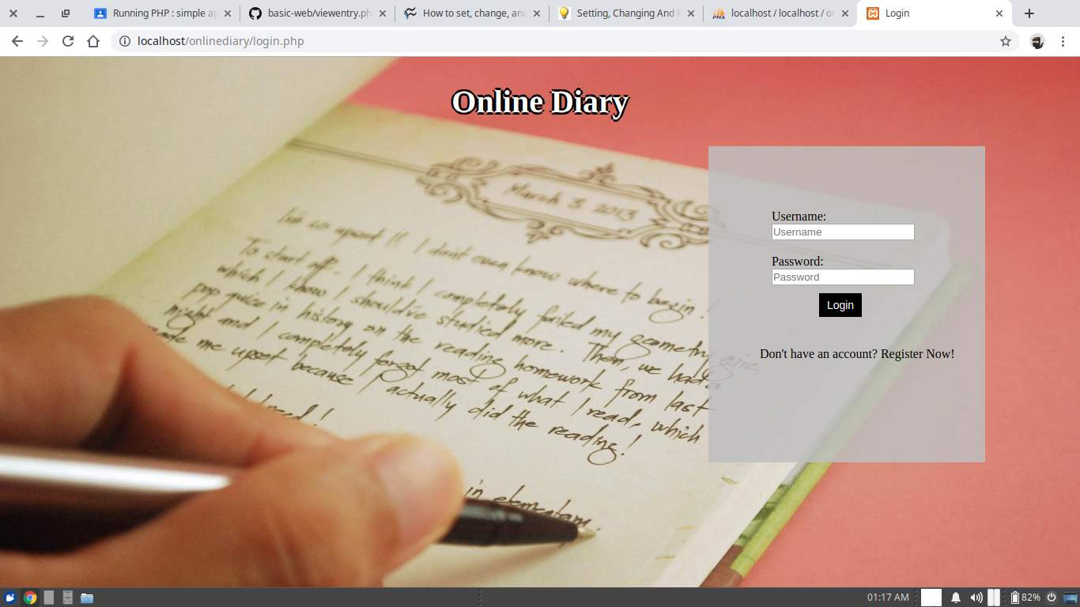

5.3.2 Registration Page
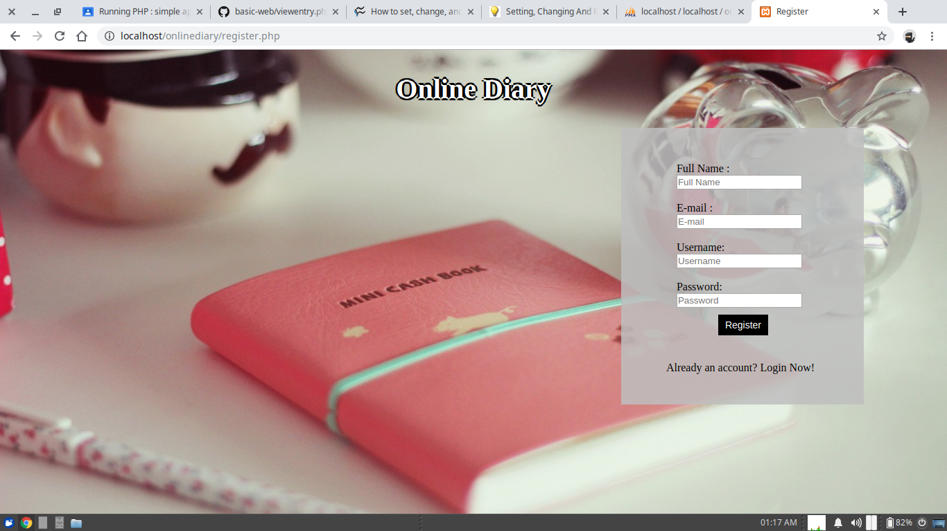
5.3.3 New Diary Entry

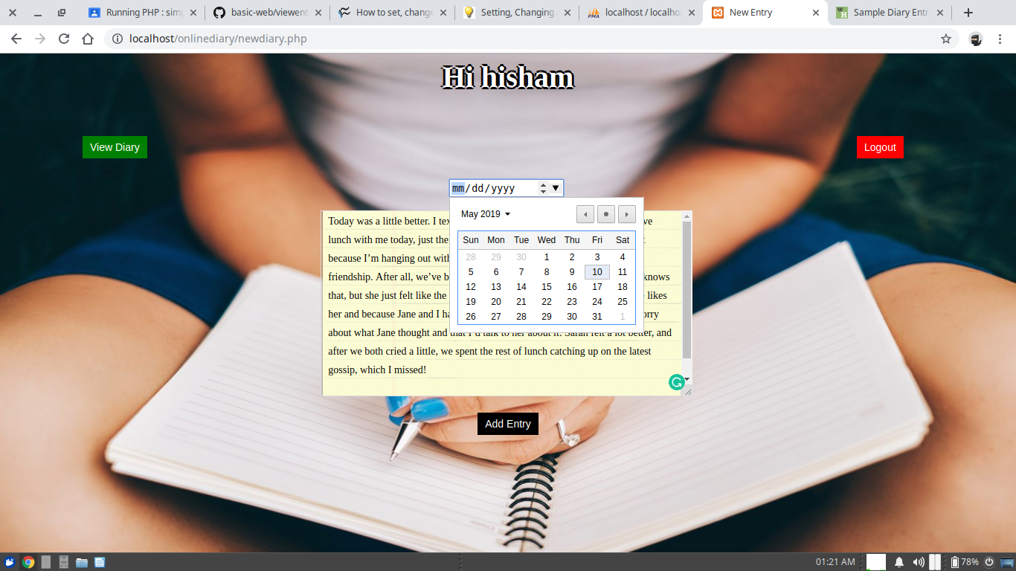

5.3.4 View Diary

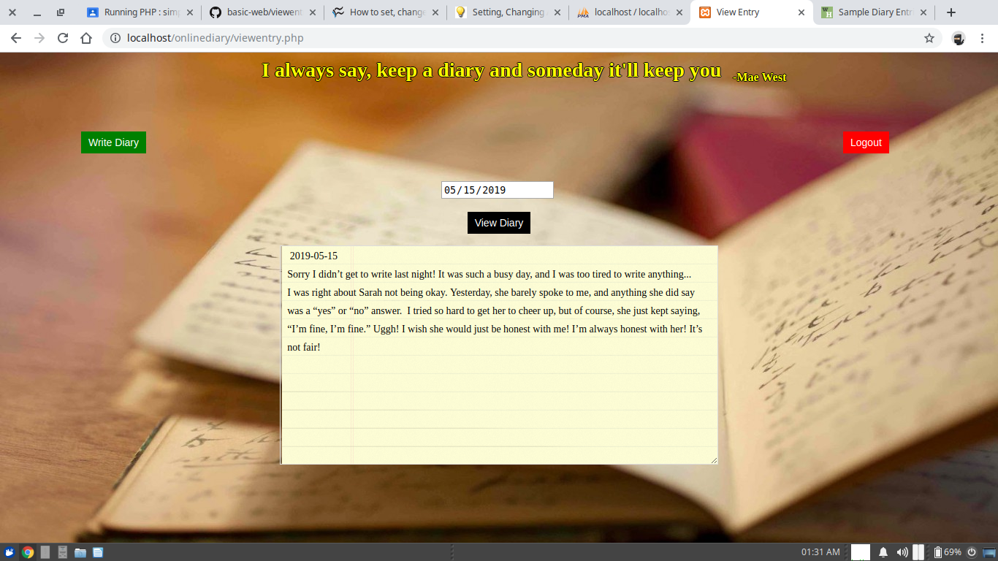
Chapter 6
CONCLUSION

Online-Diary is a web application to keep track of your journal. Online-Diary keeps your journals safe with a safe password protection so you can rest easy knowing that your entries are secure. This project is a web application which runs in a web server so that users of any platforms can access the system to utilize its resources and features.
There is only one module in proposed system, which is user module. Users can create written entries similar to a standard personal journal whenever they register into the system with user credentials. The User Interface is made user friendly.
We had try to fulfill all the requirements that are specified in the project abstract and all the necessary steps are taken for further development.
Chapter 7
REFERENCES

[1] https://en.wikipedia.org/
[2] https://stackoverflow.com/
[3] https://www.geeksforgeeks.org
[4] https://www.w3schools.com/
[5] https://codepen.io/
[6] https://www.sololearn.com/Course/
[7] https://www.youtube.com/

